

Government and Politics

A LEVEL GOVERNMENT AND POLITICS

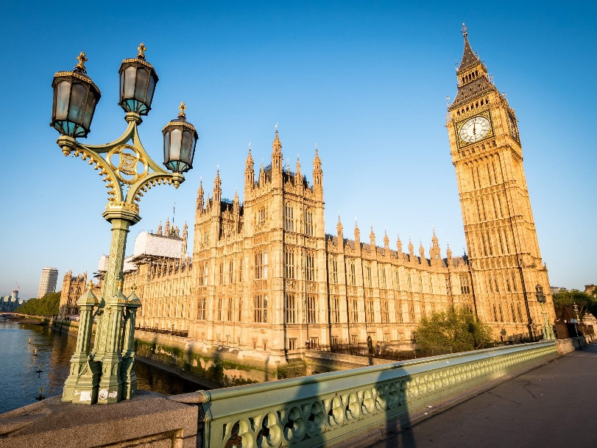

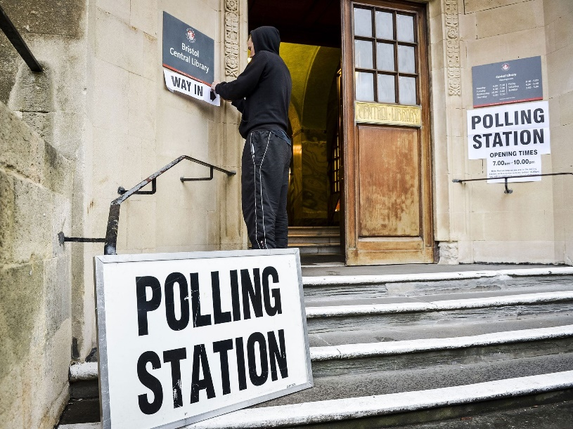

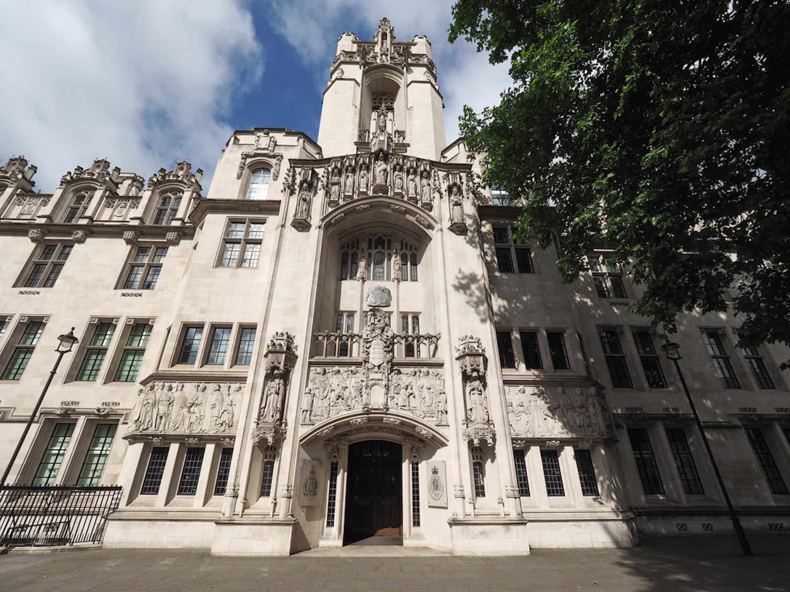

WHAT WILL I STUDY?

The course specification can be accessed here (**Edexcel Specification**):

[A level Politics - Specification (pearson.com)](https://qualifications.pearson.com/content/dam/pdf/A%20Level/Politics/2017/Specification%20and%20sample%20assessments/A-level-Politics-Specification.pdf)

The course is split into three distinct areas, two of which you will study in Year 12 and the other area you will study in Year 13.

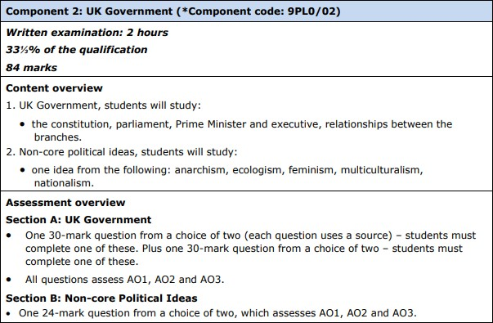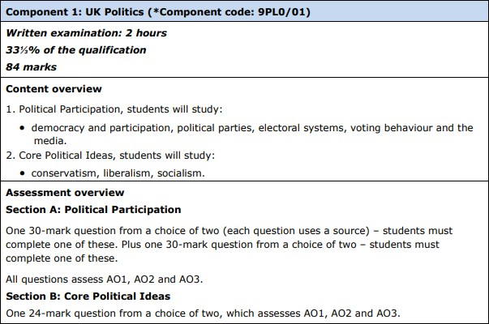

**Year 12- You will study feminism**

**Year 12**

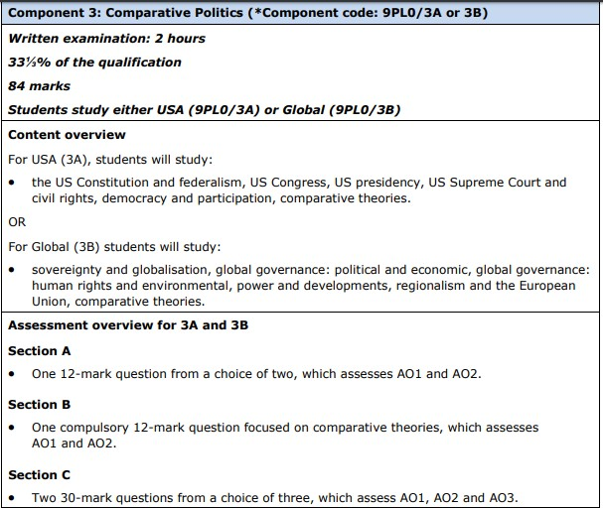

**Year 13**

The skills you will develop studying politics:

* Knowledge and understanding of different political ideas , concepts, structures and processes, the relationship between them and how they work at different levels.
* An ability to interpret and analyse political information in various forms and from various sources, and to apply a range of political ideas concepts and theories.
* An ability to evaluate arguments, theories, values and ideologies to explain political behaviour and suggest solutions to controversial issues.
* The skills to organise and present an argument with relevance, clarity and coherence using good English.

**SUMMER TRANSITION WORK**

We are so excited to hear that you are hopefully going to be joining us in September to study A Level Government and Politics.

This booklet will give you a brief introduction to the course layout and help you to start getting to grips with some of the key terminology and ideas in preparation for September.

**The first term** there are 2 topics we will study. These 2 topics will contribute towards the first 2 final exams you will sit in the summer of Year 13.

These two topics are:

1. Democracy and Participation (Why people get involved in politics)
2. The UK Constitution

Please complete the 4 tasks below and bring this completed workbook with you in September. We have also added some links and information about future Career Pathways in Politics, with links for you to do some research!

**Best wishes, Team Gov and Pol**

**\*SUMMER TRANSITION WORK HAND IN WEEK: 8th – 12th SEPTEMBER**

Task One – Parties and Issues

To start, you should quickly research the Conservative, Labour, Liberal Democrat and Reform UK parties. What do they stand for? Then, use the internet, textbooks and your imagination to create your own political party which will stand at the next election. You should include the party’s name, some points as to what the party stands for and three key policies your party will introduce if they are elected including *why* you would introduce them. These policies will cost money - will people have to pay more tax or would you make savings elsewhere? You have to justify your decisions. Some topics to consider might be:

Health, Crime, Housing, Education, Immigration

You should use the internet to research their key manifesto policies from the July 2024 general election.

You should also make a note of the turnout at the general election (how many people voted) and what percentage voted for each party and how many seats do they have in the House of Commons?

Task Two – Prime Minister and His Cabinet

Politics is a subject which cannot be unplugged from news and current affairs- it is always changing!

**Task:**

Research the Prime Minister and his Core Executive. (this means his cabinet office).

You should draw yourself a diagram to represent this, considering what departments each of the cabinet ministers lead. You will be assessed on your knowledge of the key individuals when we return in September.

**Challenge-** You might want to also keep an eye on any changes that occur in this over the summer- why did the ministers change and what impact might this have had on the prime minister?

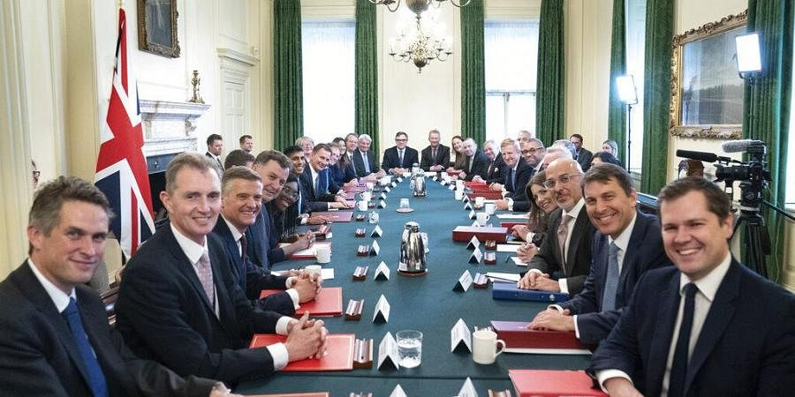

Task Three – Extended reading- The UK Constitution

Read the below article and answer the following questions in good detail.

1. **What do we mean by the UK Constitution?**
2. **Why has the structure of the UK Constitution been an area of discussion in recent years?**
3. **How has the Constitution been adapted or evolved in recent years? Describe at least two changes**
4. **What positives are there to an uncodified constitution?**
5. **What positives are there to a codified constitution?**

It is often difficult to see past media portrayals of the UK as hurtling from one political crisis to the next. As these crises mount, so too do calls for the UK to reorganise its governing and constitutional arrangements, usually by codifying them into one clear and plainly understood document. The continued informal reliance on elected officials behaving responsibly, goes the argument, will surely lead to a crisis too big to be muddled through.

Yet conversely, the resignations of both Boris Johnson and Liz Truss and the process of electing successors – under rules involving Conservative MPs and party members drawn up by the 1922 Committee – proved to be a relatively well-mannered and widely accepted transition from one political head of state to the next. An event that can be extraordinarily problematic in many states, regardless of the constitutional arrangements in place, was resolved compliantly in the UK.

Comparisons could be drawn with Donald Trump, who lengthily refused to acknowledge the result of the 2020 US presidential election and was accused of inciting an insurrection in 2021 to thwart the inauguration of his successor, and with supporters of Brazil’s former president, Jair Bolsonaro, who stormed the country’s Congress, Supreme Court and the presidential palace to protest against Bolsonaro’s replacement by his left-wing rival, Luiz Inácio Lula da Silva (Lula).

So, while students of politics could be forgiven for looking at proceedings in the UK over recent years and seeing a constitution that provides insufficient clarity, little restraint and unsatisfactory guidance when needed most, there are alternative perspectives that portray the UK’s constitutional arrangements in a much more positive light.

**Arguments for retention**

Many states have struggled with the economic difficulties, social upheaval and health-crisis uncertainties of recent years. Constitutional variations across the globe indicate that such issues occur irrespective of whatever constitutional arrangements exist. Yet the UK has shown on many occasions that it is indeed underpinned by functioning and effective constitutional principles. While often taken for granted in the UK, these factors reflect levels of constitutional restraint and responsibility that are both impressive and unique.

**Respect for democratic outcomes**

In the run-up to 2014, the Scottish National Party (SNP) was predominant in Scotland, indicating that voters supported a party that was committed to achieving an independent Scotland. The UK government agreed to the holding of a referendum, the result of which could have dissolved the United Kingdom, yet it guaranteed to respect the result. Comparisons are often drawn with Spain, where pro-independence Catalan leaders were imprisoned for sedition and disobedience in 2017 for defying the refusal of the Spanish government to engage in dialogue about a Catalonian independence referendum.

**Peaceful transitions of power**

Momentum behind the holding of a referendum about the UK’s membership of the EU led to its inclusion in the Conservative Party’s 2015 manifesto. David Cameron was the prime minister who called – and subsequently lost – the 2016 vote. Cameron stood down, to be replaced by Theresa May, who committed to delivering the result. When May struggled to maintain support for her approach, she was in turn changed for Boris Johnson in 2019, who delivered Brexit. In 2022, Johnson himself was replaced by Liz Truss when, post-Brexit, he no longer commanded the support and confidence of his party in Parliament. And less than 2 months later, Liz Truss was required to resign, having lost the confidence of her party, making way for Rishi Sunak.

**Constitutional evolution and adaption**

Codified constitutions are often criticised for being static and inf lexible. The UK’s uncodified arrangements allow for governing procedures to adapt over time to better suit or respond to the wishes of citizens. The fact that there are no entrenched constitutional arrangements – no specially protected parts of the UK’s governing structures – means that anything can be changed with a simple Act of Parliament. Examples of recent constitutional innovations include:

■ Where once referendums were considered ‘alien to our traditions’ and too often ‘the instruments of Nazism and fascism’ (Clement Attlee), they are now a firm feature of the UK’s democratic makeup.

■ The Fixed-term Parliaments Act (2011) sought to put Parliament on a similar ‘fixed-term’ footing to that of the USA. While it negated the ability of a prime minister to call a general election to suit party-political circumstances, it was scrapped in 2021 because it failed to foresee the continuation of a government that could not control the Commons.

■ The Human Rights Act (1998) enshrined the European Convention on Human Rights into British domestic law to better protect rights. In 2022, debate centred upon whether this should be replaced with a British Bill of Rights.

From the creation of devolved governments, a UK Supreme Court and elected mayors, to the introduction of alternative electoral systems and reforms to the House of Lords, the UK’s constitution has adapted to move with the times. Arrangements are permanently evolving to reflect a democratic system that is not forever bound by hallowed texts, which themselves can lack clarity and relevance.

But , what would be your view on this?

**POLITICS KEYWORD GLOSSARY**

|  |  |
| --- | --- |
| Term | Explanation |
| Power |  |
| Authority |  |
| Legitimacy |  |
| Government |  |
| Politics |  |
| Civil society |  |
| Executive branch |  |
| Prime minister |  |
| Cabinet |  |
| Legislative branch |  |
| Parliament |  |
| House of  Commons |  |
| House of Lords |  |
| Rule of Law |  |
| Elective  dictatorship |  |
| Direct  democracy |  |
| Representative democracy |  |
| Sovereignty |  |
| Parliamentary  sovereignty |  |
| Referendum |  |
| Constitutional  monarchy |  |

|  |  |
| --- | --- |
| Devolution |  |
| Labour Party |  |
| Conservative  Party |  |
| Liberal Democrats |  |
| Reform UK |  |

**READING/WATCHING/LISTENING**



The following are suggestions, they are not compulsory, but we would love for you to engage in any that you find interesting.



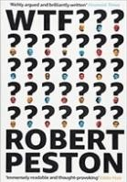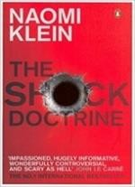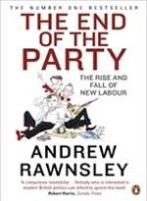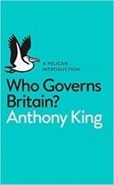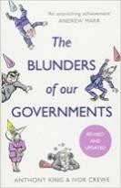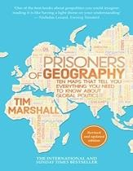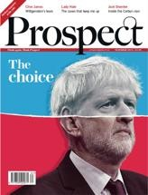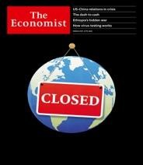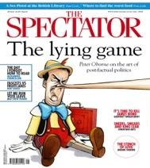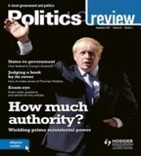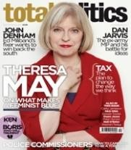

|  |  |
| --- | --- |
| Theatre |  |

|  |  |  |
| --- | --- | --- |
| Headphones | [Stitcher – A-level politics podcast](https://www.stitcher.com/podcast/alevel-politics-podcast) [Beyond Westminster](https://www.bbc.co.uk/programmes/b00g6spw)  [BBC politics podcasts](https://www.bbc.co.uk/search?q=politics&suggid) [The Westminster Hour](https://www.bbc.co.uk/programmes/b006s624) [Politics.co.uk podcasts](https://www.politics.co.uk/podcast/) | [Guardian ‘politics weekly’ podcasts](https://www.theguardian.com/politics/series/politicsweekly) [Going the way of the dodo](https://www.bbc.co.uk/programmes/m0006shh?fbclid=IwAR3FGxbFGXmWSMPCpdu6ftBBzM6JNeyM_DTXS84ab2Wnc6pAngkFjykDrcU)  [10 of the best podcasts](https://www.theguardian.com/tv-and-radio/2018/jun/17/political-podcasts-10-of-the-best) [Takes from the lobby](https://www.bbc.co.uk/sounds/play/m0006mr6) [Learn out loud podcasts](https://www.learnoutloud.com/category_podcast.php?cat=0&catid=26&level=0&id=26) |

|  |  |  |
| --- | --- | --- |
| Television | [iPlayer Climate Change Playlist](https://www.bbc.co.uk/iplayer/search?q=climate%2Bchange) [World economic forum videos](https://www.weforum.org/videos/archive/) [Politics Live – BBC iPlayer](https://www.bbc.co.uk/iplayer/episodes/b0bjf8p5/politics-live)  [The Andrew Marr Show](https://www.bbc.co.uk/iplayer/episodes/b0080bbs/the-andrew-marr-show) [The Politics Show](https://www.bbc.co.uk/programmes/b00b2qm1) | [Question Time](https://www.bbc.co.uk/programmes/b006t1q9) [BBC Parliament](https://www.bbc.co.uk/tv/bbcparliament)  [Cabinet Confidential](https://www.youtube.com/watch?v=wdAhv0D1_hc)  [Globalisation if Good – Johan Norberg](https://www.youtube.com/watch?v=12YDLZq8rT4&t=352s) |

**Career Pathways in Politics:**

**Top Politics Universities:**

Oxford [University of Oxford | Course Finder (thecompleteuniversityguide.co.uk)](https://www.thecompleteuniversityguide.co.uk/courses/university-search/undergraduate/politics/university-of-oxford)

University College London [UCL (University College London) | Course Finder (thecompleteuniversityguide.co.uk)](https://www.thecompleteuniversityguide.co.uk/courses/university-search/undergraduate/politics/ucl-university-college-london)

London School of Economics [London School of Economics and Political Science, University of London | Course Finder (thecompleteuniversityguide.co.uk)](https://www.thecompleteuniversityguide.co.uk/courses/university-search/undergraduate/politics/london-school-of-economics-and-political-science-university-of-london)

**Local Universities:**

Southampton University [University of Southampton | Course Finder (thecompleteuniversityguide.co.uk)](https://www.thecompleteuniversityguide.co.uk/courses/university-search/undergraduate/politics/university-of-southampton)

Portsmouth University [University of Portsmouth | Course Finder (thecompleteuniversityguide.co.uk)](https://www.thecompleteuniversityguide.co.uk/courses/university-search/undergraduate/politics/university-of-portsmouth)

**Politics careers:**

